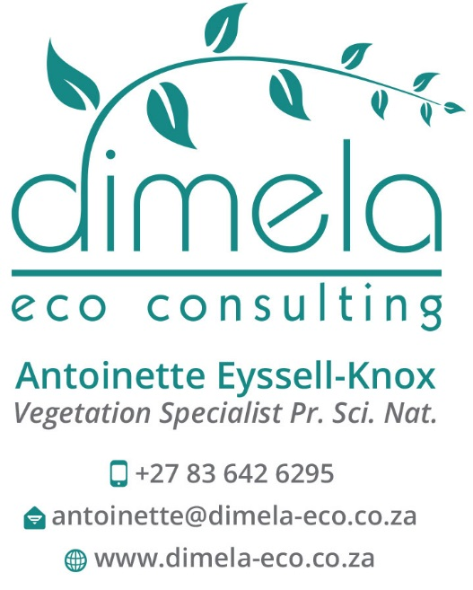

Curriculum Vitae and abbreviated Company Profile

Antoinette Eyssell-Knox
Pr Sci Nat (400019/11) Ecological Science

TABLE OF CONTENTS
1. Employment record 2
2. Qualifications 2
3. Professional membership: SACNASP 2
4. Specialist Work experience 3
APPENDIX A: MSc 9
Appendix B: SACNASP 10

LIST OF TABLES
Table 1: Employment record: Environmental Assessments 2
Table 2: Employment record: Other 2
Table 3: Project experience 3

EMPLOYMENT RECORD
I am currently self-employed and am the sole proprietor of Dimela Eco Consulting. I have been working in the field of environmental impact assessment since 2007 (9 years) (Table 1).

Table 1: Employment record: Environmental Assessments
Time frame | Title | Company
Nov 2011 - current | Sole proprietor, vegetation specialist | Dimela Eco Consulting
Sep 2007 – Nov 2011 | Terrestrial Ecologist, specialising in vegetation | Strategic Environmental Focus (SEF)

Prior to working in the environmental impact assessment field, my main work experience was gained at the Pretoria National Botanical Gardens where I have developed much of my knowledge on indigenous plants.

Table 2: Employment record: Other
Time frame | Title | Company
Aug 2003 – Sep 2007 | Snr Environmental Education  Officer | Environmental Education Centre, Pretoria National Botanical Garden, South African  National Biodiversity Institute (SANBI)
Jun – Jul 2003 | Horticultural Trainer | 17 Shaft Training Centre, Johannesburg
May 1997 – Mar 2002 | Horticulturist | Pretoria National Botanical Garden (then NBI, now SANBI)

QUALIFICATIONS
- M.Sc Environmental Science, University of Pretoria (2010)
Dissertation: Land cover change and its effect on future land uses
- B. Sc (Hons) Horticulture, University of Pretoria (1999-2000)
Dissertation: Horticultural uses of the indigenous Barleria species
- B. Sc (Agriculture) Horticulture, University of Pretoria (1993-1996)

Proof of MSc – Appendix A

PROFESSIONAL MEMBERSHIP: SACNASP
Registered as a Professional Natural Scientist with the South African Council for Natural Scientific Professionals (SACNASP)
SACNASP Reg no 400019/11 Proof of certificate – Appendix B

SPECIALIST WORK EXPERIENCE
Dimela Eco Consulting is an independent consultancy which offers a range of services pertaining to the integration of vegetation, vegetation ecology, protected plants and other ecological concerns into the development and land use process. In support of sustainable development, green infrastructure and socially responsible progress, Dimela Eco Consulting provides clients with quality, unbiased and reliable reports to help minimise the impact on the receiving natural environment and to inform effective decision making by providing the following services:

- Vegetation assessments;
- Vegetation overviews or scans;
- Strategic ecological assessments, including wetland input;
- Mitigation measures to reduce impacts on the natural environment;
- Ecological management and biodiversity action plans (including alien vegetation management);
- Specialist input: ecological conditional requirements for Green Star rating;
- Ground-truthing of vegetation related data; and
- Review of ecological reports.

In addition, Antoinette Eyssell has 4 years’ experience in Environmental Education and Greening Projects at the South African National Biodiversity Institute (SANBI) (2003-2007). In this time, she mentored four students over two year period as part of an internship programme.

She currently writes the ecology feature for the bimonthly Supernova Kids Magazine and welcome opportunities to stay involved in environmental education and related community programmes.

The table below list some of Dimela’s projects, since 2012.

Table 3: Project experience
PROJECT  NAME | INDUSTRY /  CLIENT | DATE | ADDITIONAL INFORMATION
Schmidsdrift, Northern Cape Vegetation Assessment for Solar Panels | V & L Landscape Architects | January 2012 | Delineation of vegetation communities, determine vegetation sensitivities and survey for plants of conservation concern. Report on potential impacts and mitigation measures to limit impacts.
Kranspoort road upgrade Protected tree identification | Lidwala | March 2012 | Identify and record localities, species and numbers of protected trees along an area earmarked for road upgrade.
Vegetation base line study and input into Biodiversity Action Plan | Kumba Iron  Ore (Anglo) via Lidwala | April-May  2012 | Undertake a gap analysis and review of existing information and update by assessing the vegetation during the summer months and suggesting monitoring plots, information to be collected and areas where sensitive vegetation should be avoided and managed.
Rietfontein  Open Cast Vegetation assessment | Cabanga Concepts | April 2012 | Delineation of vegetation communities, determine vegetation sensitivities and survey for plants of conservation concern. Report on potential impacts and mitigation measures to limit impacts.
Eskom: Perseus to Gamma Vegetation assessment | Mokgope Environmental Consultants | October  2012 | Survey the proposed route options and compare the floral assemblages that are expected to occur within the area to the actual vegetation found to be present along the route options. Map the localities of plants of conservation concern that was identified during the field survey or suitable habitat where these plants could potentially occur. Assess impacts and determine route alignment that is likely to have the least impact on sensitive vegetation
Vierfontein  Colliery Vegetation assessment and  EMP input | Cabanga Concepts | January  2013 | Assess the current impacts of the open cast mine on the vegetation and provide input into the EMP to conserve and limit impact on conservation worthy vegetation that persist on the site
Diepsloot Eskom line and substation,  Johannesburg  (Gauteng | Envirolution | March 2013 | Survey the preferred and alternative route alignments and compare the floral assemblages that are expected to occur within the area to the actual vegetation found to be present along the routes. Map the vegetation / habitat types according to structurally distinct vegetation units as well as transformed areas, as well as the localities of threatened plant species. Recommend mitigation measures to aid the conservation of vegetation during construction and operation and indicate the route that will have the least impact on the vegetation.
Komati Power Station – Coal stockyard  Vegetation opinion | ESKOM | May 2013 | Assess the potential plant species and vegetation communities that could be impacted by the proposed increase in capacity of the coal stockyard. Recommend mitigation measures to avoid or limit the potential negative impacts that the proposed activity could have on the surrounding vegetation.
Tshepong Mine, assessment and Biodiversity Action Plan (BAP) | Harmony | November 2013 – Feb 2014 | - Undertake baseline assessments for fauna, flora and wetlands;  - Compile a Biodiversity Action Plan (BAP) based on the baseline assessments  - Compile an alien invasive plant management plan for the site
Eskom: Northern Alignments (Perseus in the Northern Cape to Juno in the Western Cape) | Mokgope Consulting | 2013 | Survey the proposed route options and compare the floral assemblages that are expected to occur within the area to the actual vegetation found to be present along the route options. Map the localities of plants of conservation concern that was identified during the field survey or suitable habitat where these plants could potentially occur. Assess impacts and determine route alignment that is likely to have the least impact on sensitive vegetation
Masa Ngwedi 750kV and 400kV lines (Limpopo and North West Provinces) Section D & E Vegetation Input for EMP | Mandara Consulting | November  2013 | Walk down with specific reference to plants of conservation concern that could occur along the proposed powerline route. A report detailing the pylons in proximity to intact and likely sensitive vegetation as well as measures to aid conservation / rehabilitation of this vegetation along the powerline routes as input into the EMP; and localities of plants of conservation concern will be mapped and used to apply for permits for the removal/destruction/pruning of these species where they might be impacted on by the powerline.
Marakele Bush  Camp | NuLeaf | December  2013 | - Site visit and meeting with the park manager with regards to the area proposed for the development  - An opinion with regards to the suitability and ecological sensitivity of the proposed area as well as the likelihood for protected plant species occurring within the development footprint.
Meteor substation, as well as the 88kV line between the Pulsar, Meteor and Sonland substations,  Sebokeng area,  Gauteng | Nsovo Environmental  Consulting | February 2014 | - Survey the preferred and alternative route alignments and substation locality;  - Compare the floral assemblages that are expected to occur within the area to the actual vegetation found to be present along the routes;  - Map the vegetation / habitat types according to structurally distinct vegetation units as well as transformed areas;  - Map the localities of plants of conservation concern that was identified during the field survey or suitable habitat where these plants could potentially occur;  - Assess the possible impacts that the proposed powerline an substation could have on the vegetation;  - Recommend mitigation measures to aid the conservation of vegetation during construction and operation; and  - Indicate the route that will have the least impact on the vegetation
Blesboklaagte & Leeupoort Township development | Shangoni | April 2014 | - Undertake a field survey and assessment of the biophysical environment and current status of natural features on the proposed site and compare the findings to the expected natural state as listed in the national vegetation map;  - Field survey with specific reference to plants of conservation concern (“red data” and provincially protected species) that could occur within the study site or immediate surroundings;  - Sensitivity mapping, including possible or confirmed localities of plants of conservation concern; and  - Report on the potential impacts that the proposed township could have on vegetation and recommend mitigation measures to limit or negate the potential negative impacts where possible.
Goldi Farm Composting Site, Section 24G  Fauna and Flora assessment and Summary document | Shangoni | May 2014 | Due to secondary state of the vegetation on site, the reports comprised an opinion with regards to the fauna and flora:  - describing the vegetation communities and fauna habitats that likely occurred on site prior to the commencement of the illegal activity, as well as natural vegetation surrounding the site;  - reference to the occurrence or possible occurrence of plants of conservation concern and threatened fauna (vertebrates) that might inhabit the site and immediate surroundings;  - map indicating confirmed or potential habitat for plant and fauna species that are of conservation concern as well as ecologically sensitive vegetation communities / fauna habitats; and  - assessing the impacts that the activities is likely to have on vegetation and fauna of conservation concern.
Upgrading of Internal Roads in Stinkwater, Hammanskraal (Gauteng) | Glad Africa | December 2014 | - Map the location and extent of all plant communities on the study site as well as the ecological sensitivity of each plant community  - A plant species list were provided for each plant community with medicinal and invasive/exotic species indicated.  - A Red List plant survey was undertaken and the site visit determined whether any of the national protected tree species occurred on or around the site  - The potential impacts, based on a supplied methodology and the proposed development, were assessed and the report recommended mitigation measures to limit the perceived impacts on sensitive vegetation.
Environmental management Plan for the Krugersdorp Nature Reserve – vegetation section | Nu Leaf and Mogale City Council | November 2014-January 2015 | - Determine the baseline vegetation communities present within the reserve  - Recommend management activities to improve deteriorated vegetation and to conserve areas of high vegetation sensitivity.  - Recommend management strategies to eradicate and control alien invasive plant species in the reserve.
Rietspruit Residential (Ekhurhuleni) | Naledi Consulting | - May 2015 | - Compare the vegetation that are expected to occur as per the National Vegetation Map, Gauteng Conservation Plan and the Ekhurhuleni Bioregional Plan, with the information gathered on site during the field survey;  - Map and discuss the vegetation groups recorded on the site and their sensitivity to the proposed development;  - Map the localities of plants of conservation concern that was identified during the field survey (if any) or suitable habitat where these plants could potentially occur;  - Assess the possible impacts that the proposed development could have on sensitive vegetation; and  - Recommend mitigation measures to aid the conservation of vegetation during construction and operation thereof.
City of Joburg  Linbro Park and Bassonia Open Space Plans | Iggdrasil Scientific Services via Royal HaskoningDHV | - Sept-Nov 2015 | - Background information pertaining to vegetation within the proposed open spaces.  - Status quo of vegetation within open spaces.  - Input into open space planning
The proposed Kaalspruit Open Space Project, Thembisa, Gauteng  Kaalspruit River Rehabilitation  Biodiversity Scan:  Vegetation and vertebrate report  (in collaboration with vertebrate specialists Dr N Rautenbach, Dr A Kemp and Jaco van Wyk | NuLeaf Planning and Environmental | - November 2015 | A biodiversity scan was requested to ascertain if any habitat for threatened plant or faunal species may be present and what the impact of the proposed rehabilitation will be on their persistence. The biodiversity scan will involve sample plots and/or transects within accessible areas and areas likely to support threatened species (areas still comprising natural vegetation).  - Carry out a high level scan for vegetation and fauna within the area proposed for rehabilitation;  - List any threatened or protected fauna and flora species found or suitable habitats that may be present;  - Map the vegetation and habitats on the basis of potential areas of concern; and  - Assessment of the impacts that the proposed rehabilitation could have on the fauna and flora (particularly sensitive assemblages if present), as well as recommendations to limit or negate these perceived impacts
N4 - Additional lane | Environamic | - February 2016 | - Research the regional background information pertaining to this section of the N4 route;  - List the threatened or protected plant and tree species that were historically recorded in the area and that have a likelihood of colonising or persisting in the servitudes;  - Undertake a site survey of the servitude;  - Map the potential sensitivities and recommend management objectives to protect and conserve potential sensitive areas / species; and  - Provide the coordinates of protected trees species / threatened species recorded in the sample areas in tabulated format.
Tharisa Mine Railway Line – Vegetation rehabilitation plan | Limosella Consulting | - January 2016 | - Providing guidelines for the re‐establishment of vegetation cover with suitable plant species;

APPENDIX A: MSC
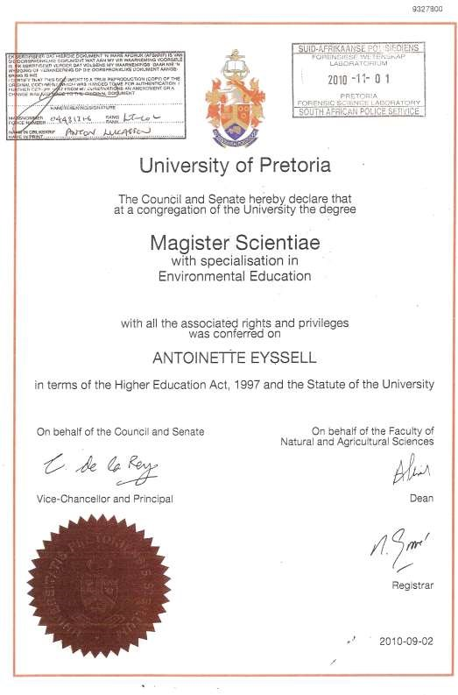

APPENDIX B: SACNASP

